Computer Language Coding Concepts

Start & Stop in a Diagram
Terms like start and stop were explained in the article Start & Stop. The current article displays their symbols.

Each of the following commands or states has a symbol:

Previous
Rollback
Faster Backwards
Slower Backwards
Reverse
Play
Slower
Faster
Go To End
Next
Pause
Wait
Timer
Not Runnable
Stop
Finished
Record
Error
Warning

The symbols are just about the same as those of media players of today:

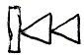 | 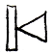 | 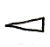 |  | 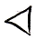
Previous | Rollback | Faster Backwards | Slower Backwards | Reverse
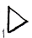 |  |  | 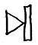 | 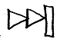
Play | Slower | Faster | Go To End | Next
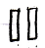 | 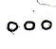 | 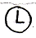 | 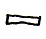 | 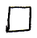
Pause | Wait | Timer | Not Runnable | Stop
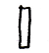 | 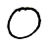 |  | 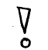
Finished | Record | Error | Warning

The commands can be displayed at the bottom of the screen to execute a selected command or on a thread, that you are following.

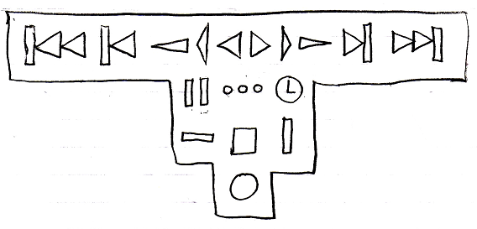

The order of the symbols may become different in practice. They will probably put in a straight line. Some of them can not even be execution commands, but can only be execution states, so those will be left out of the bottom of the screen.

Another example display of the execution commands and execution states:

The following symbols are also possible candiates:

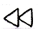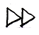

Those symbols could set the speed of going foreward or backward, gradually changing it from Faster Backwards, Reverse, Slower Backwards and to Slower, Play, Faster. The first symbol simply decreases the speed or makes it go faster backwards, and the second symbol simply increases the speed or makes it go slower backwards.

The symbols for actions, that a media player also has, were retained, because I just love symbolic representation and I do not see a need to invent any other symbolic display for this.

An execution state is also be displayed at the bottom of a command symbol, to indicate its state:

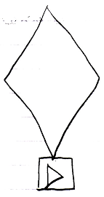

The executable command above is currently running at normal speed, since it is in Play state. Here are more examples of executable command object in different states.

The following command is paused:

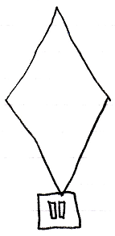

The following command is finished:

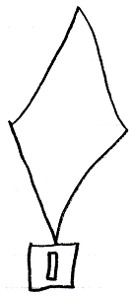

The following command is recording:

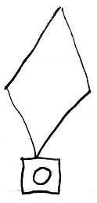

The following command is not executable at all:

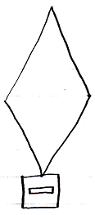

Any execution state can be indicated for a command object like that.

See also: Start & Stop, Commands

Author & Copyright: Jan-Joost van Zon Date: August 13, 2008 – August 29, 2008 Location: Oosterhout, The Netherlands Status: Finished

